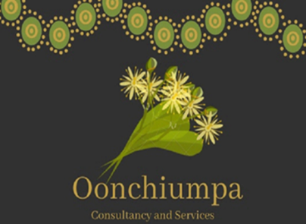

Oonchiumpa Consultancy and Services

24 Parsons Street

Alice Springs NT 0870

Phone: 0474 702 523

Email: [admin@oonchiumpaconsultancy.com.au](mailto:admin@oonchiumpaconsultancy.com.au)

***“Two Cultures, One World, Working Together”***

**Good News Story**

**Oonchiumpa Fellas Day Out – Standly Chasm**

Fred and Tyrone took Darius Ross and Jayden White out on country to Standly Chasm.

Standley Chasm is on western Arrernte country where you can hear first-hand from Aboriginal tour guides about the cultural stories of the area and see cultural significant sights.

This was a great activity/opportunity for the young fellers to hear from Aboriginal tour guides and see Aboriginal staff serving in the local café leading the way of what many Aboriginal People can do on the own lands.

